**Question – 1 Write a program to calculate the sum of numbers stored in an array of size 10. Take array values from the user.**

**Ans.**

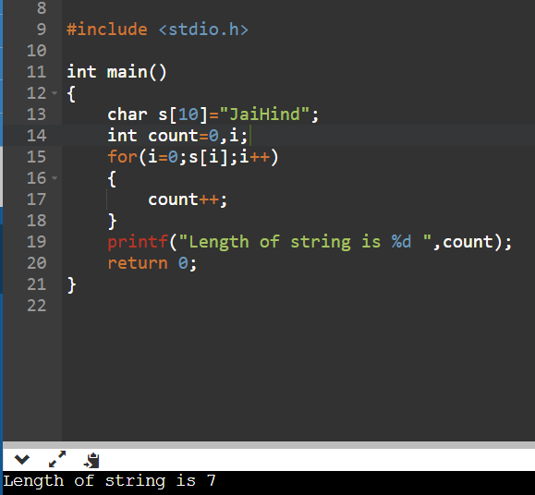

**Question – 2 Write a program to count the occurrence of a given character in a given string.**

**Ans.**

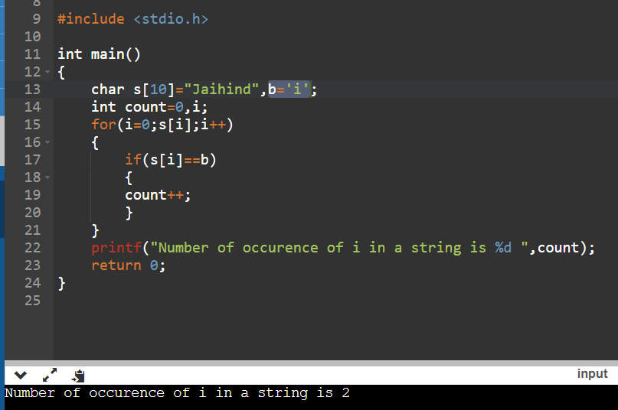

**Question – 3 Write a program to count vowels in a given string.**

**Ans.**

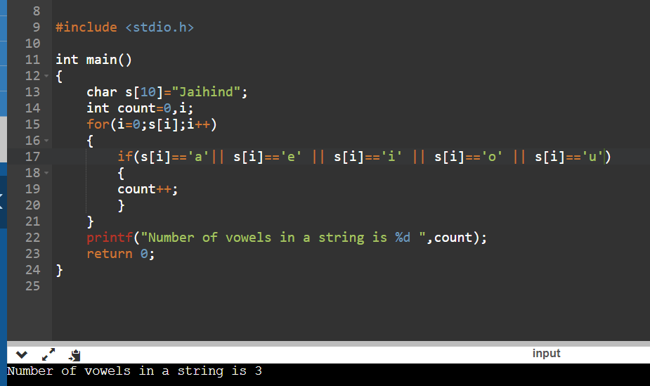

**Question – 4 Write a program to convert a given string into uppercase.**

**Ans.**

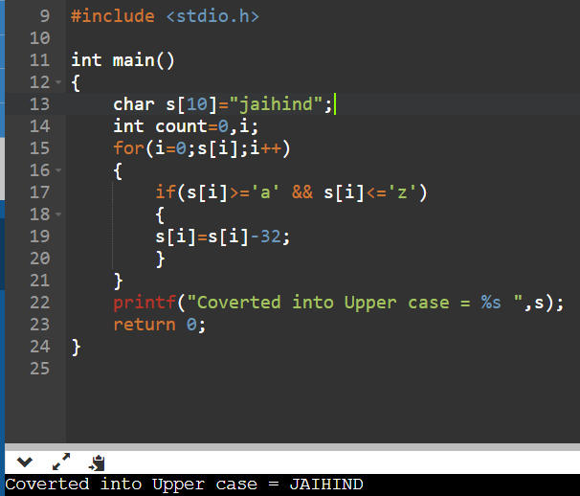

**Question – 5 Write a program to convert a given string into lowercase.**

**Ans.**

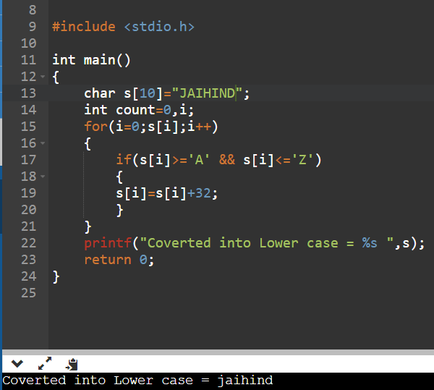

**Question – 6 Write a program to reverse a string.**

**Ans.**

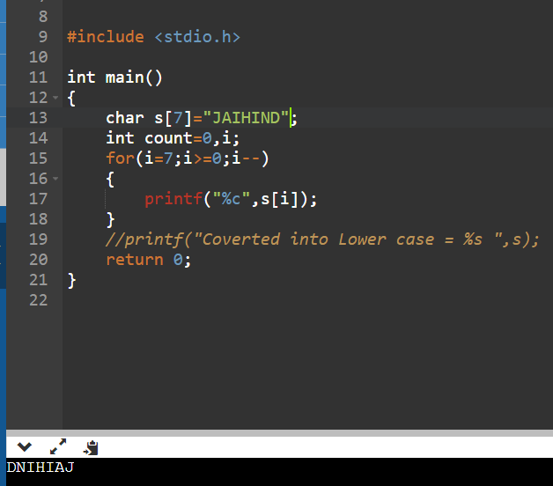

**Question – 7 Write a program in C to count the total number of alphabets, digits and special**

**characters in a string.**

**Ans.**

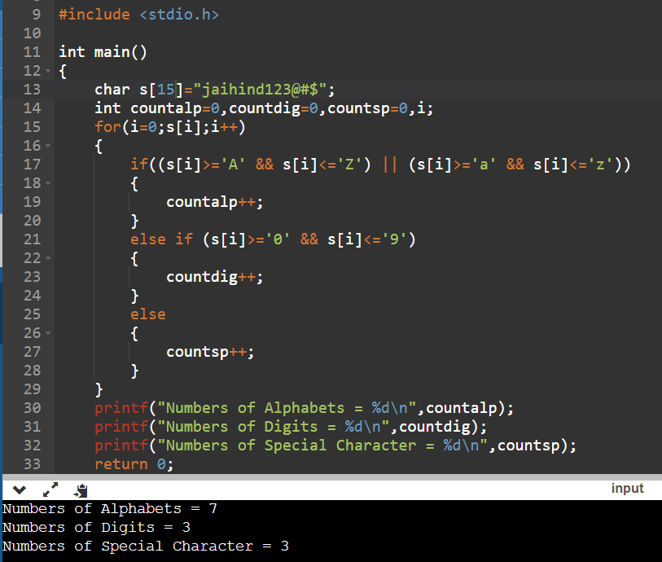

**Question – 8 Write a program in C to copy one string to another string.**

**Ans.**

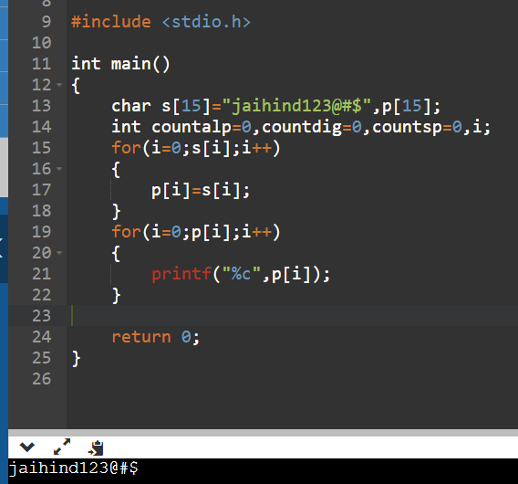

**Question – 9 Write a C program to sort a string array in ascending order..**

**Ans.**

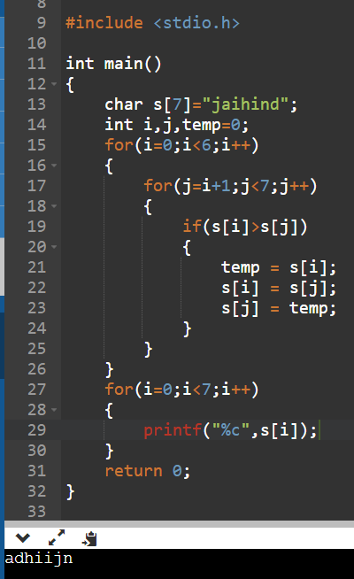

**Question – 10 Write a program in C to Find the Frequency of Characters.**

**Ans.**

